Scholarship Research 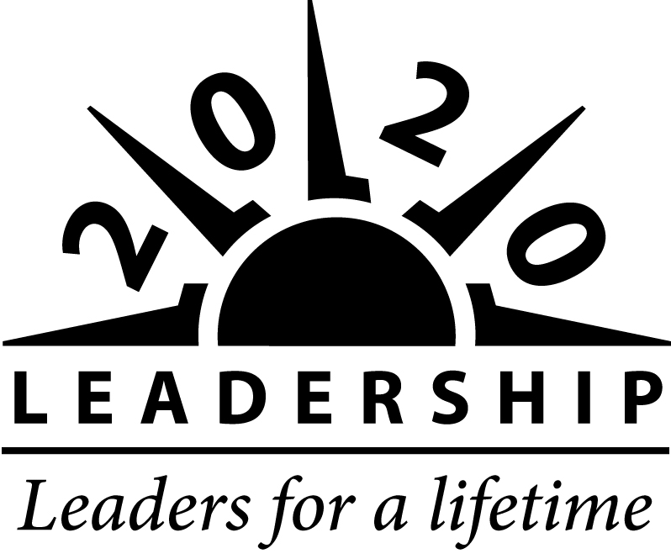
913-721-3933(office)
816-520-0014 (cell)
malstrom@2020leadership.org
www.2020leadership.org

www.2020leadership.org
- Five –$10,000 KC Royals Charities Scholarships
- Two 20/20 Alumni $500 Scholarship (Male/Female)
- Gene Denton Memorial Scholarship--$1,000
- Great Achiever Scholarship--three $1,000
- Hubert & Dorothy Archer Education Scholarship--two $1,000

www.gkccf.org – Scholarship
Kansas Students
- Automobile Dealers of Greater KC Scholarship
- 1,000 Dreams Scholarship Fund
- AABE William Grant Pinkard Scholarship
- Black Community Scholarship Fund
- Black Scholarship Fund
- Bright Futures Scholarship Fund
- D.J.B. & Mrs. Isabella Bisceglia Scholarship Fund
- Dr. Risdon Memorial Development Award – must attend college in LV County
- Drug Free Sport Fund Continuing Education Award
- Electric League – check it out ---
- Elizabeth Miller Watkins Memorial Scholarship Fund – Girls – attending KU
- Epps Scholarship Fund
- Go-Long Scholarship Fund
- Genevieve Edmee Lenz Guldner KU Fine Arts Scholarship
- General Hospital #2 Perpetual Trust Fund Scholarship (African-American students)
- Hispanic Development Fund Scholarship Program
- James R. Goheen Scholarship Fund – Wyandotte Co. and USD#500 students
- Jeffrey C. Wicina Wrestling Scholarship Fund
- Kansas Foster & Adoptive Children Scholarship Fund
- Kansas City Securities Asso. Educational Fund --- Schlagle students read carefully
- Kreider Scholarship Fund – Bonner Springs Students
- Kris Paper Legacy Scholarship for Women in Technology Fund
- Mid-West Concrete Industry Board Educational Fund – check out
- New Theatre Guild Scholarship Endowment Fund – KU, UCM, UMKC
- Pastor Otis L. Cobbins, Sr. Memorial Scholarship – Wyandotte County student
- Second Chance Scholarship Fund
- Siplon Family Foundation Scholarship
- Tony DiPardo Instrumental Music Foundation Scholarship Fund
- Transition into Post-Secondary Studies (TIPS) Scholarship
- Zonta Club of Johnson County, Kansas Scholarship Fund
- Zach Myers Memorial Firefighter Scholarship – Johnson Co student

www.gkccf.org

Missouri Students
- Kansas City Missouri Opportunities Scholarship Fund
- 1,000 Dreams Scholarship Fund
- AABE William Grant Pinkard Scholarship
- Automobile Dealers of Greater KC Scholarship
- Beatrice Priscilla Stewart Scholarship
- Black Community Scholarship Fund
- Black Scholarship Fund
- Bright Futures Scholarship Fund
- Drug Free Sport Fund Continuing Education Award
- Epps Scholarship Fund
- General Hospital #2 Perpetual Trust Fund Scholarship (African-American students)
- Go Long Foundation
- Gordon M. Robinson Memorial Scholarship Fund
- Hispanic Development Fund Scholarship Program
- Jenese Lynn Krysa Scholarship Fund
- Kansas City Securities Association Educational Fund – University Academy/Boys & Girls Club
- Kansas City Missouri Opportunities Scholarship Fund
- Kris Paper Legacy Scholarship for Women in Technology Fund
- Leopold Gallery Scholarship Fund – Paseo Academy Students
- Marvin Brooks Education Fund—HS in Jackson County
- Michael Haseltine Scholarship Fund – Jackson County student – Disability field interest
- Mid-West Concrete Industry Board Educational Fund – check out
- New Theatre Guild Scholarship Endowment Fund – KU, UCM, UMKC
- Paul D. Strohm Scholarship Fund – Northeast HS students
- Robert A. Long Scholarship Fund – Southeast HS students
- Second Chance Scholarship Fund
- Siplon Family Foundation Scholarship
- Tony DiPardo Instrumental Music Foundation Scholarship Fund
- Top Ten of Tomorrow
- Transition into Post-Secondary Studies (TIPS) Scholarship
- Jann Link Memorial Golf Scholarship – Jackson County – girl – who plays golf
- Jeffrey C. Wicina Wrestling Scholarship Fund
- KC Securities Association Education Fund – check out to see if you qualify

